
Name : Ch Mubashir.
SAP : 56892.
Course : Data Visualization (BS-DS-6-1).
Instructor : Uzair Rasheed.
Date : 2-23-2026

Contents
*LAB TASK 04* 3
Task Information 3
Lab Purpose 3
Steps : 3
Part 1 3
Step 1 Import Libraries 3
Libraries 3
Screenshot : 4
Explanation : 4
Step 2 Loading Dataset : 4
Code : 4
Screenshot 5
Step 3 Understanding Data Structure 5
Code : 5
Screenshot : 5
Explanation : 6
Step 4 Summary Statistics : 6
Code : 6
Screenshots : 7
Explanation : 8
Part 2 8
Step 5 Visualizing Distributions : 8
5.1 Histograms (Professional Version) 8
Code : 8
Screenshots: 8
Explanation : 9
5.2 KDE Plot (Target Variable) 9
5.3 Boxplot (Outlier Detection) 10
5.4 Correlation Heatmap (Professional) 11
Strongest Features with SalePrice 12
Top 5 Positive Correlations 13
Exercise 1 – 5 Highly Skewed Variables 14
Exercise 2 – 3 Strongest Predictors 15

*LAB TASK 04*

Task Information
Lab Type: Exploratory Data Analysis (EDA) Part (a) - Python
Dataset: “House Prices – Advanced Regression Techniques”
Source: Kaggle

Lab Purpose
- Understand dataset structure
- Compute summary statistics
- Analyze distributions
- Detect missing values
- Perform correlation analysis
- Generate basic insights

Steps :

Part 1

Step 1 Import Libraries

Libraries
import numpy as np
import pandas as pd
import matplotlib.pyplot as plt
import seaborn as sns from scipy.stats
import skew, kurtosis

Screenshot :
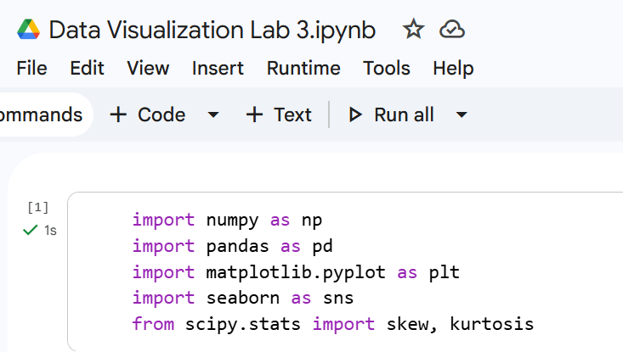

Explanation :
- NumPy → numerical operations.
- Pandas → data handling.
- Matplotlib/Seaborn → visualization.
- SciPy → statistical metrics.

Step 2 Loading Dataset :

Code :
# Load dataset
df = pd.read_csv("/content/train.csv")
# View first 5 rows
df.head()

Screenshot
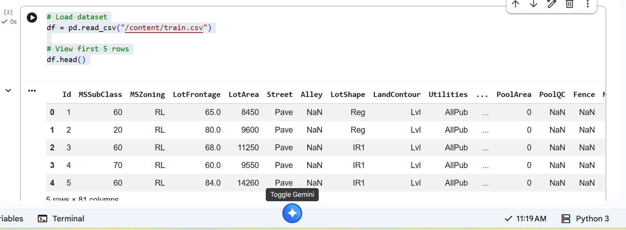

Step 3 Understanding Data Structure

Code :
df.info() # View rows, columns, and types
print(df.isnull().sum().sort_values(ascending=False)) # Missing values
print(df.duplicated().sum()) # Duplicate check

Screenshot :
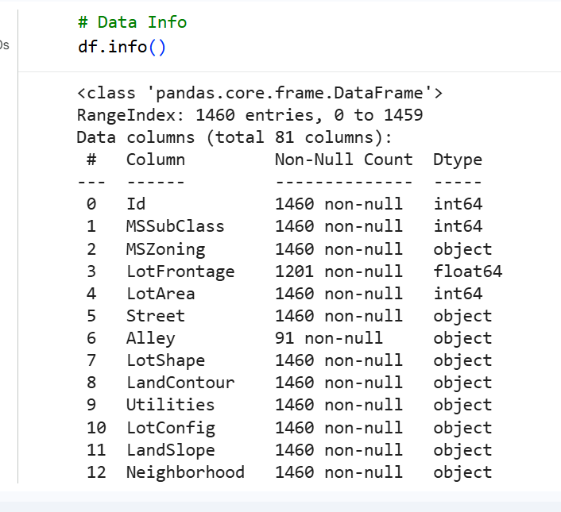

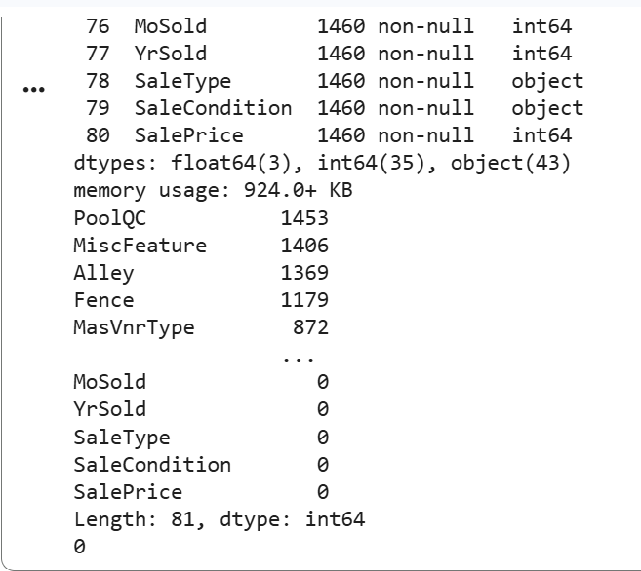

Explanation :
- Significance : Explain that identifying missing values is the first step in data cleaning. Mention that duplicate checks ensure the integrity of the statistical analysis and prevent biased results.

Step 4 Summary Statistics :

Code :
# Summary Statistics (Mean, SD, Quartiles) [cite: 39, 41, 42, 44]
print("\nSummary Statistics:\n", df.describe()) # [cite: 39]
# Skewness & Kurtosis [cite: 45]
# Skew > 1 is highly skewed; Kurtosis > 3 has heavy tails [cite: 48, 49]
skewness = df.skew(numeric_only=True).sort_values(ascending=False) # [cite: 46]
print("\nTop Skewed Variables:\n", skewness.head(10))

Screenshots :
Code
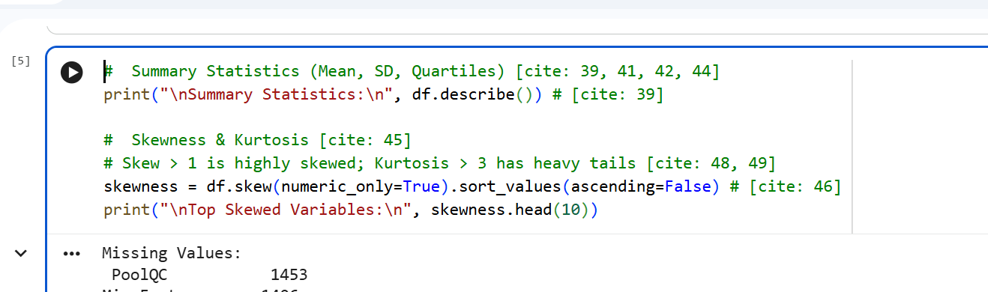
Output :
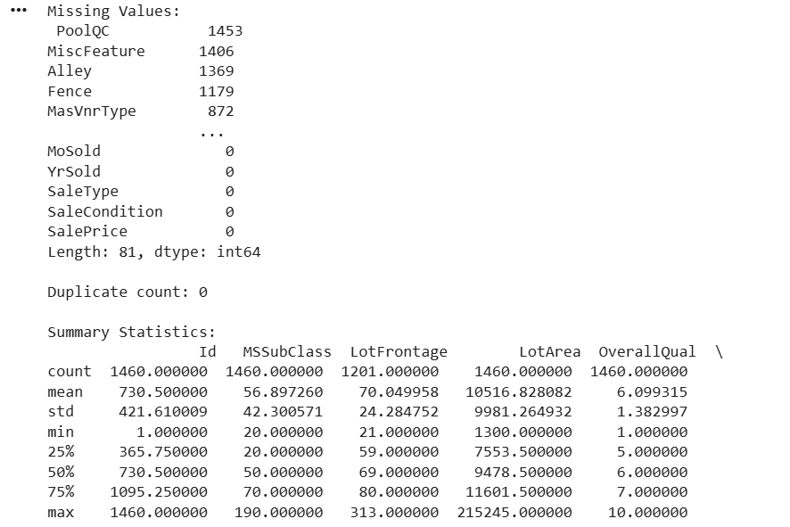

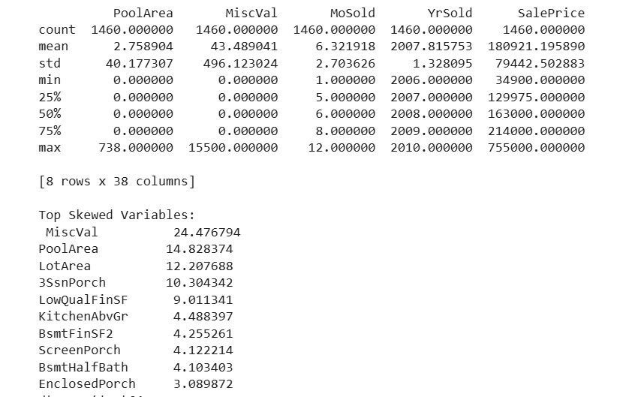

Explanation :
- Significance : Discuss how the SalePrice mean compares to the median. Explain that high skewness indicates the presence of outliers that might require data transformation before modeling.

Part 2

Step 5 Visualizing Distributions :

5.1 Histograms (Professional Version)

Code :
df.hist(bins=30, figsize=(18,15), color='steelblue', edgecolor='black')
plt.tight_layout()
plt.show()

Screenshots:
Code :
Output :
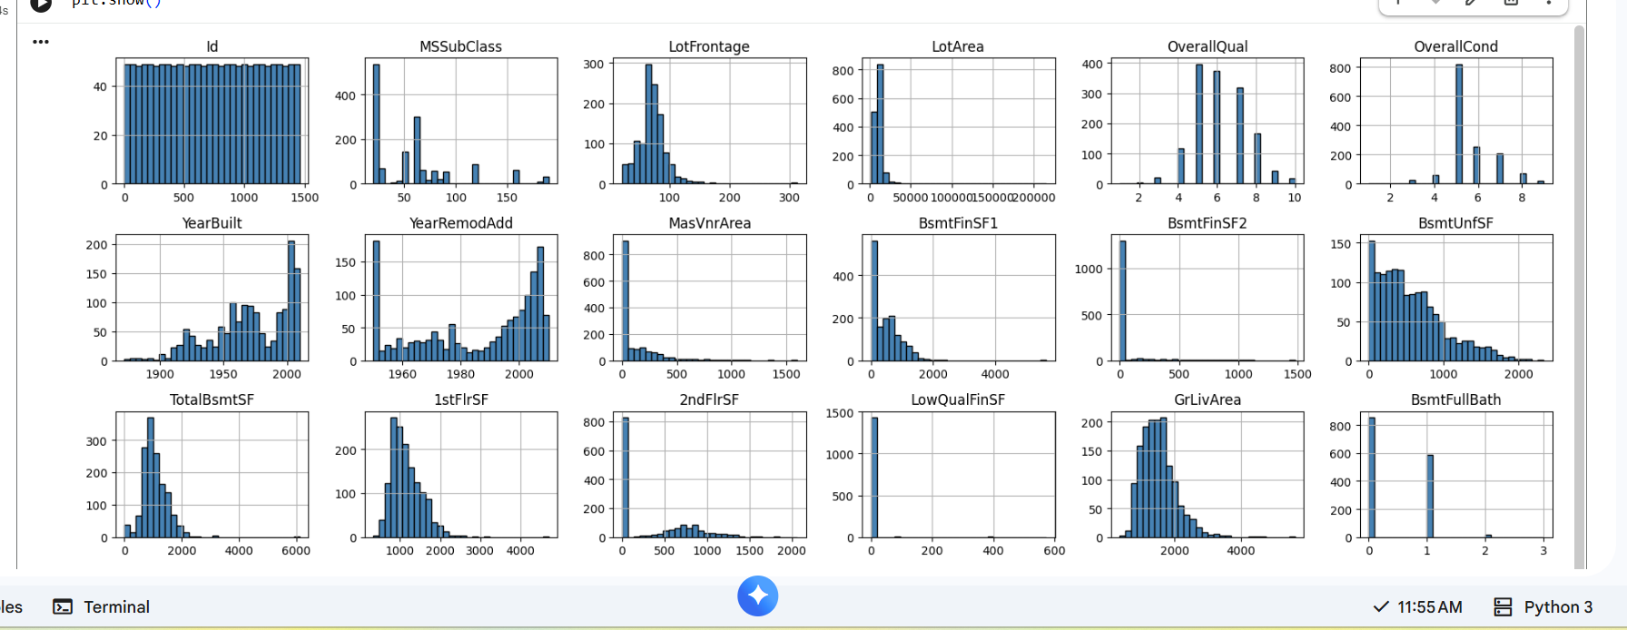
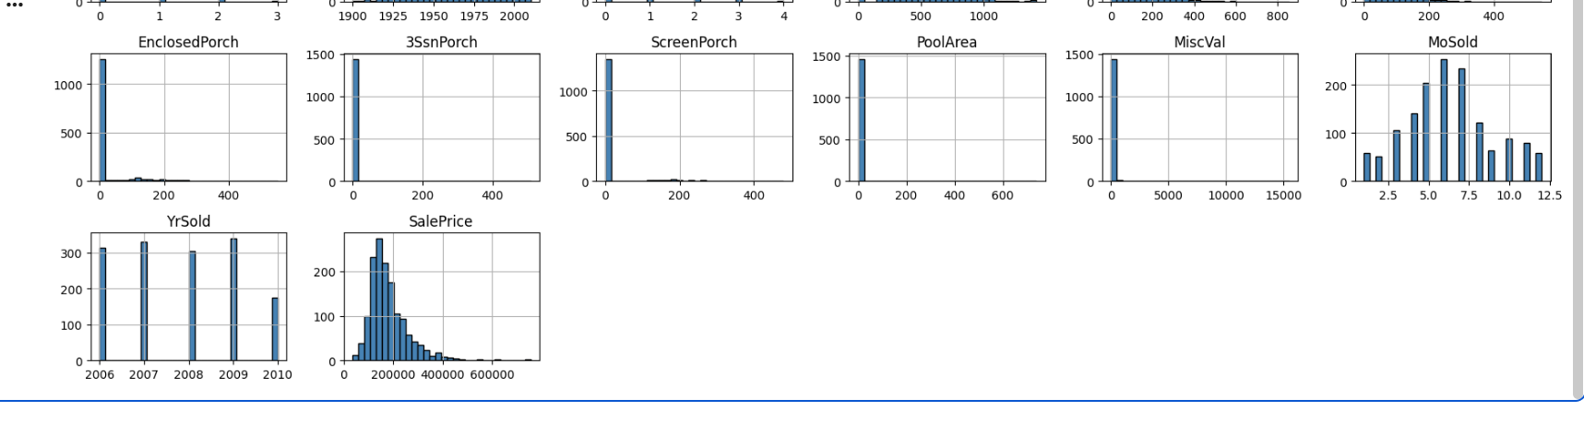

Explanation :
- Report Insight Several features show right-skewed distributions, particularly SalePrice and LotArea, indicating presence of high-value outliers.

5.2 KDE Plot (Target Variable)

Code :
plt.figure()
sns.kdeplot(df['SalePrice'], fill=True, color='darkblue')
plt.title("Distribution of SalePrice")
plt.xlabel("SalePrice")
plt.show()

Screenshots :
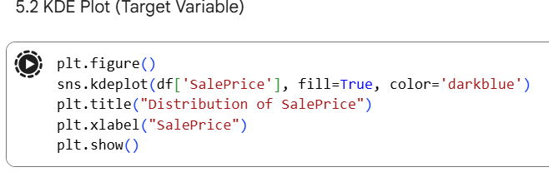

Interpretation
- Right skewed distribution
- High-value properties create long tail

5.3 Boxplot (Outlier Detection)

Code :
plt.figure()
sns.boxplot(x=df['SalePrice'], color='orange')
plt.title("SalePrice Boxplot")
plt.show()

Screenshot
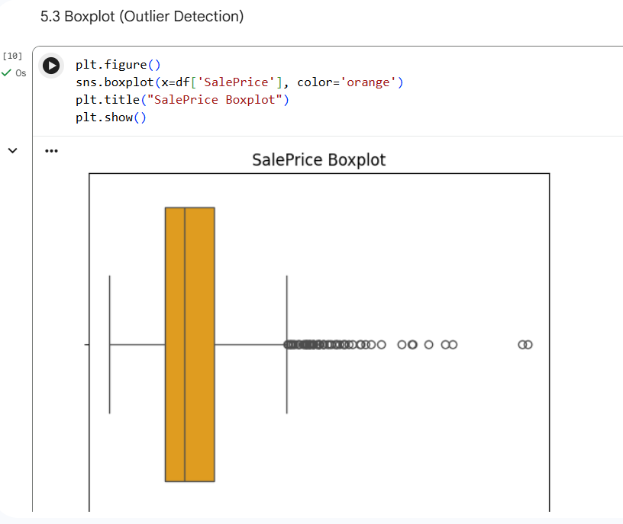

Interpretation
- Median line
- IQR range
- Extreme upper outliers visible

5.4 Correlation Heatmap (Professional)

Code :
plt.figure(figsize=(14,12))
corr_matrix = df.corr(numeric_only=True)

sns.heatmap(corr_matrix, cmap='coolwarm', center=0)
plt.title("Correlation Heatmap")
plt.show()

Screenshots:
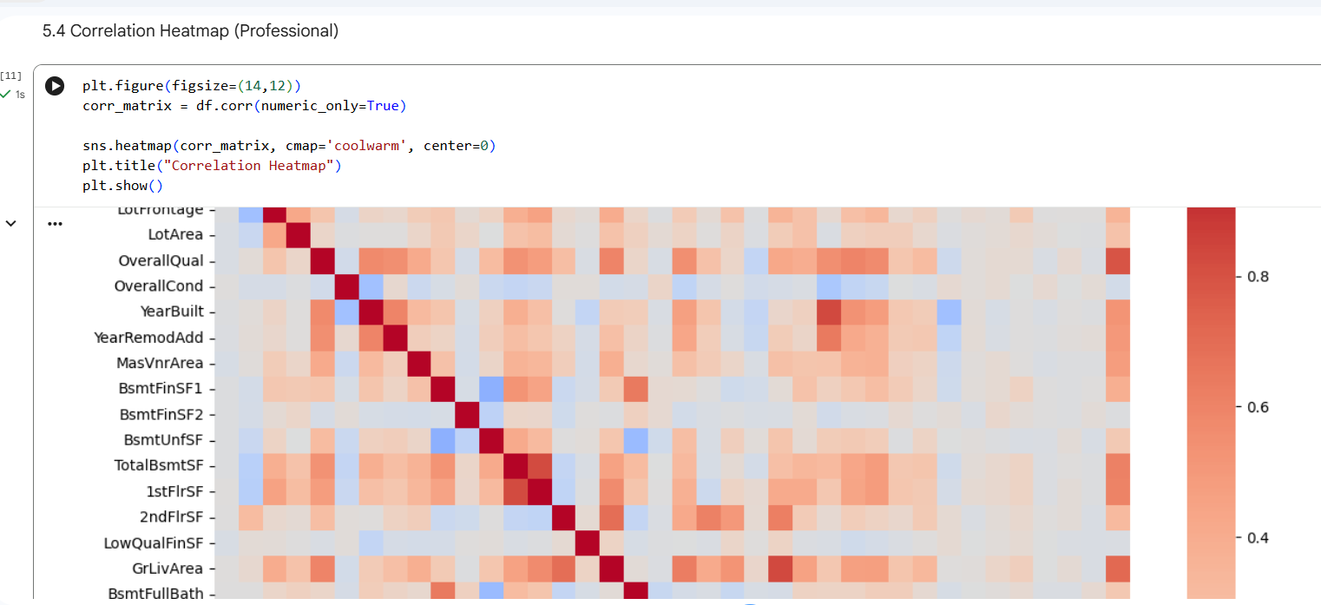

Strongest Features with SalePrice

Code :
corr_matrix['SalePrice'].sort_values(ascending=False)

Screenshots :
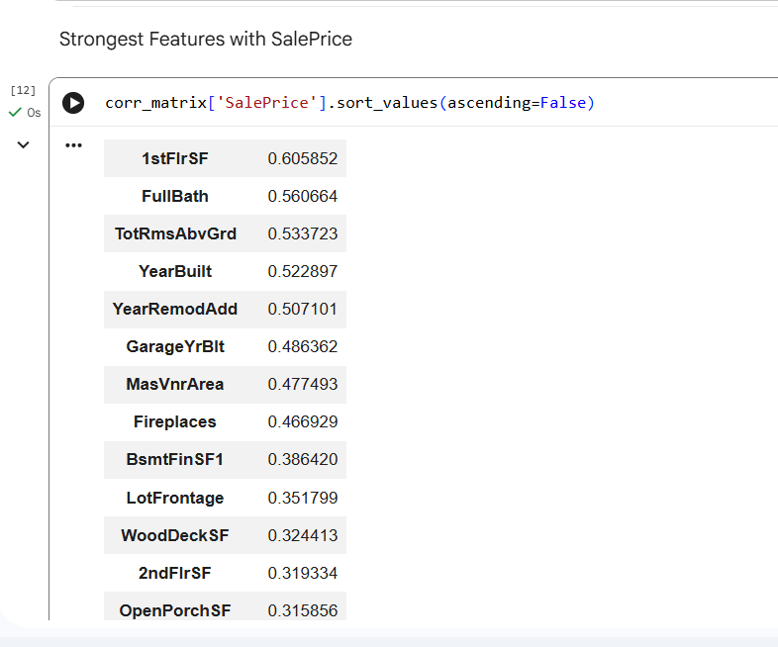

Top 5 Positive Correlations

Code :
top_features = corr_matrix['SalePrice'].abs().sort_values(ascending=False).head(6).index
sns.pairplot(df[top_features])
plt.show()

Screenshots:
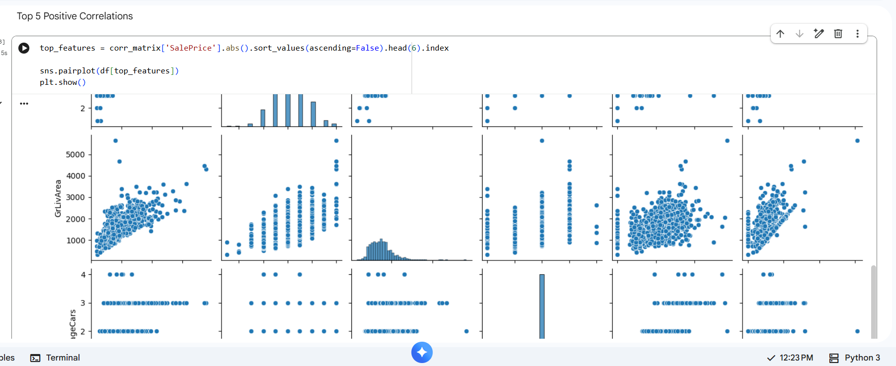

Exercise 1 – 5 Highly Skewed Variables

Code :
skewness[skewness > 1].head(5)
df['SalePrice_log'] = np.log1p(df['SalePrice'])

Screenshots :
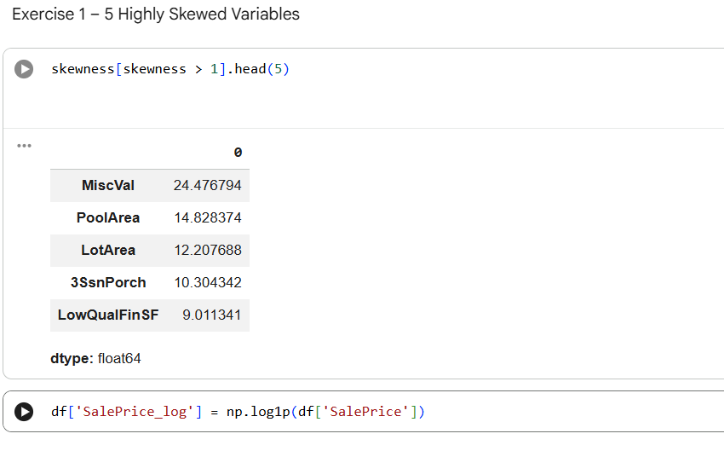

Suggested Transformation:
- Log transformation.
- Box-Cox transformation.

Exercise 2 – 3 Strongest Predictors
Likely:
- OverallQual
- GrLivArea
- GarageCars
Justify using:
- Correlation values
- Pairplot relationships

